SPANISH TITLE
ENGLISH TITLE (MAXIMUM LENGTH: 20 WORDS)

¹Author Name *, ^{2,n}Author Name, ^{n}Rosa Maldonado Pujos
¹University, Faculty, Department, City, Country
²University, Faculty, Department, City, Country
^{n}University, Faculty, Department, City, Country

Author Name 1, ORCID, E-mail
Author Name 2, ORCID, E-mail
Author Name n, https://orcid.org/0000-0002-6344-4130, E-mail
E-mail: * contact mail
Resumen
This document is an example of the format ruled by the publication guidelines of “Perfiles” Scientific Journal in terms of writing representative articles. Authors must follow the instructions, including paper format and size in order to maintain the publication standard. This document can be interpreted as a set of instructions for writing an article or as a template for doing so. The abstract should contain from 150 to 200 words, besides, it cannot contain formulas or acronyms. It should summarize the theoretical framework that justifies the work developed, well-defined objectives, methods used, results and main conclusions.
Palabras Clave: Six words maximum, which define the most important points of the work.

Abstract
It must be written in English, the maximum length is from 150 to 200 words; it cannot contain formulas or acronyms. It should summarize the theoretical framework that justifies the work developed, well-defined objectives, methods used, results and main conclusions.
Keywords: Six words maximum, which define the most important points of the work.

Introduction
Its aim is to identify the theoretical framework, which will be contextualized with the phenomenon to be investigated to determine the work general and specific objectives. It must not contain excessive bibliographical references or abbreviations.

MATERIALS AND METHODS
This section must contain all the information regarding methodology and experimental materials used. Besides, it will allow the essay to be reproducible under the same conditions as those indicated by the authors. If the authors recur to other procedures designed and published by others, these publications should be appropriately referenced.
If there are figures/images, the structure of presenting is:

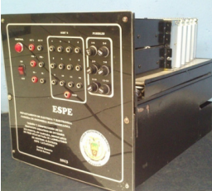
Figure 1. Final module of the single phase didactic multilevel cascade inverter

Regarding FIGURES OR IMAGES they must be sent in PNG or JPG format. As long as possible they should have high resolution, additionally, each figure should be listed with their respective description in bold and italic.
If there are equations they should be listed as follows:

$$F=q(\overset{⃑}{E}+\overset{⃑}{v} x \overset{⃑}{B})$$ | (1)
$$\overset{⃑}{P}=\overset{⃑}{p}+\frac{e}{c} \overset{⃑}{A}$$ | (2)

Results
This is perhaps the most important section of all research work in which some figures and tables are commonly included.

It contains all the information related to the findings achieved, once the statistical methods have been applied (if necessary).

It could be incorporated tables, diagrams, or any other additional elements that expands and/or facilitates the presentation of results.

An example of a table structure (Table 1) can be seen in below:
Compuesto | Cantidad
Citrato Férrico | 0.10 gr
Estracto de Peptona | 3 gr
MgCl₂ | 8.8 gr
Na₂SO₄ | 3.3 gr
CaCl₂ | 1.8 gr
KCl | 0.6 gr
NaCl | 19.5 gr
NaHCO₃ | 0.16 gr
Agua Destilada | 1000 ml

Table 1. Composition of culture medium.

Each table should be listed with a respective description in bold and italic.

To express results in terms of statistical graphs, the following should be considered:

In such cases, be sure to use the appropriate resolution, so that the figure can be clearly seen in the document. (1)

Do not use low-resolution figures because impoverishes the quality article. When inserting a figure, be sure to verify the following:
• The colours contrast appropriately,
• The image is clear,
• Any text in the image can be read clearly.
An example is shown below:
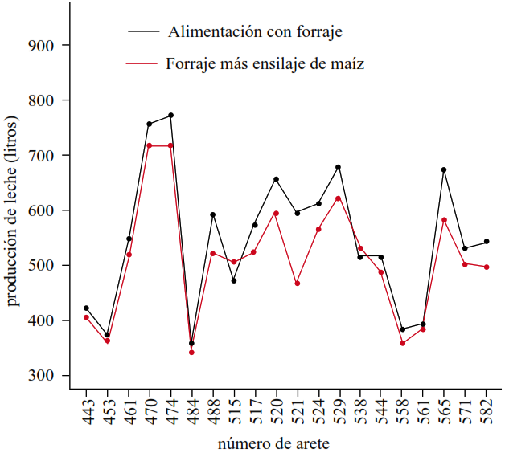
Figure 2. Milk production of 20 cows fed with forage in July and with forage plus corn silage in August.
It must be to colours as can be seen for the identification and have title; both horizontal and vertical axes must be with the respective name. (2)

Discussion
In-depth analysis of the data obtained, comparing with other authors. This section should discuss the most innovative and important results, the contribution and applicability, etc.

Conclusions
Clear, direct and concise answers to the initial questions or objectives of the study. It may include proposals for new lines of research based on the results discussed or new hypotheses must always be supported by the results.

Acknowledgements
People or institutions that have contributed in some way to the research or drafting text, whether through funding, knowledge contribution or research activity.

CONFLICTO DE INTERESES
Indicate whether particular interests exist on the part of the authors or the scientific entity that could directly or indirectly affect the results.(3)

References
Note: Both in the text-quotes- as in the Reference Bibliography must meet the standards of The International Committee of Medical Journal Editors (ICMJE) or FORMAT 4 of the VANCOUVER STYLE. The incorporation of grey literature or content of dubious origin or scientific quality (especially of web source) will be considered a serious mistake and reason for rejection of the publication proposal. Publications used in the bibliography must belong to indexed journals with the corresponding identifier: DOI (Digital Object Identifier), ISBN (International Standard Book Number) or ISSN (International Standard Serial Number).(4)
1. UNISEC México: University Space Engineering Consortium. Formato IEEE para presentar artículos. 2015;3.
2. Lee DJ, Show KY, Su A. Dark fermentation on biohydrogen production: Pure culture. Bioresour Technol. 2011;102(18):8393–402.
3. Boltzmann EP, Atmospheric W, Energy T. Fundamental Physical Constants. Phys Today. 2013;
4. Luican A, Li G, Andrei EY. Quantized Landau level spectrum and its density dependence in graphene. Phys Rev B - Condens Matter Mater Phys. 2011;

